
Customer Engagement & Product Utilization Analytics for retention strategy using machine learning
[Document subtitle]


ABSTRACT

Customer retention has become one of the most critical challenges in the banking industry due to increasing competition and changing customer behavior. This project focuses on Customer Engagement and Product Utilization Analytics for Retention Strategy using Machine Learning and Interactive Business Intelligence Dashboards.
The objective of the project is to identify customer churn patterns, analyze customer engagement behavior, detect high-value disengaged customers, and provide AI-driven retention strategies. The project utilizes banking customer data containing demographic, financial, and behavioral attributes.
Exploratory Data Analysis (EDA) was performed to understand customer behavior patterns and identify factors influencing customer churn. Feature engineering techniques were applied to improve model performance and business interpretability. Machine Learning models were used for churn prediction, and the final system was integrated into an interactive Streamlit dashboard for real-time analytics.
The dashboard provides customer segmentation, churn insights, product utilization analysis, retention strategy recommendations, and churn prediction functionality. The system helps banks improve customer engagement, reduce churn, and increase long-term customer retention.

1. INTRODUCTION

Customer retention is one of the most important objectives in the banking sector. Acquiring new customers is significantly more expensive than retaining existing customers. Banks continuously face challenges in understanding customer behavior, product usage patterns, and churn risks.
With the growth of Artificial Intelligence (AI) and Machine Learning (ML), banks can now analyze customer engagement patterns and proactively identify customers likely to leave the bank. Predictive analytics enables organizations to take strategic actions before customer churn occurs.
This project aims to develop a customer engagement analytics system that helps banks:
- Analyze customer behavior
- Detect churn risks
- Identify disengaged high-value customers
- Improve retention strategies
- Enhance product utilization
- Provide AI-driven business insights
An interactive Streamlit dashboard was developed to visualize customer analytics and support decision-making.

2. PROBLEM STATEMENT

Banks often struggle to identify customers who are likely to discontinue services. Traditional customer management systems fail to provide real-time engagement insights and proactive retention recommendations.
The major problems addressed in this project are:
- High customer churn rates
- Lack of customer engagement analysis
- Difficulty identifying high-risk customers
- Poor retention strategy planning
- Limited product utilization insights
This project solves these issues using Machine Learning-based customer analytics and intelligent dashboard visualization.

3. OBJECTIVES

The main objectives of this project are:
- To analyze customer engagement behavior.
- To identify churn-prone customers.
- To analyze product utilization patterns.
- To detect high-value disengaged customers.
- To provide AI-driven retention strategies.
- To build an interactive Streamlit dashboard.
- To improve banking retention decision-m
4. DATASET DESCRIPTION

The dataset used in this project contains banking customer information with demographic, behavioral, and financial attributes.

Feature | Description
CustomerId | Unique customer identifier
Surname | Customer surname
CreditScore | Customer creditworthiness
Geography | Customer location (France, Spain, Germany)
Gender | Male / Female
Age | Customer age
Tenure | Years with the bank
Balance | Account balance
NumOfProducts | Number of bank products
HasCrCard | Credit card ownership
IsActiveMember | Customer activity indicator
EstimatedSalary | Estimated annual salary
Exited | Churn indicator (Target Variable)

5. METHODOLOGY

The project follows the following workflow:
Step 1: Data Collection
The banking customer dataset was collected and imported using Pandas.
Step 2: Data Cleaning
- Missing values were checked
- Duplicate records were removed
- Data types were validated
Step 3: Exploratory Data Analysis (EDA)
EDA was performed to identify:
- Customer distribution
- Churn behavior
- Product utilization trends
- Activity patterns
- Financial characteristics
Step 4: Feature Engineering
New categorical and numerical features were created to improve prediction performance.
Step 5: Machine Learning Model Building
Machine Learning models were trained to predict customer churn
Step 6: Dashboard Development
A Streamlit dashboard was developed for interactive analytics and visualization.
Step 7: Retention Strategy Recommendation
AI-driven retention strategies were generated based on customer behavior patterns.

6. EXPLORATORY DATA ANALYSIS (EDA)

EDA helped identify important patterns and insights related to customer engagement and churn.

- Inactive Customers Show Higher Churn -
Customers with low activity levels were more likely to leave the bank.

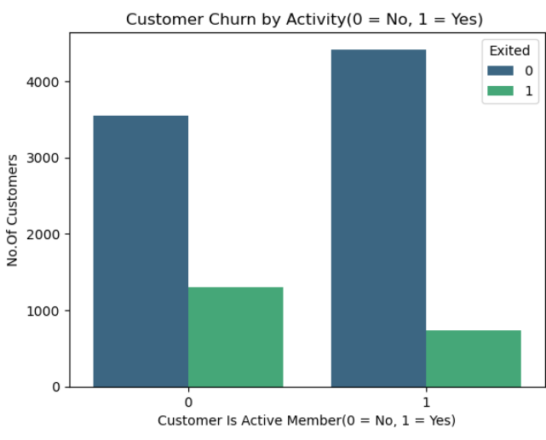

- Single-Product Customers Are High-Risk -
Customers using only one banking product showed higher churn probability

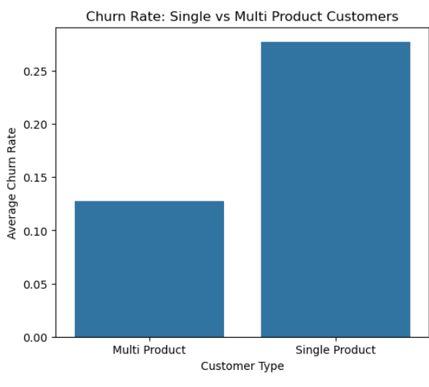

- High-Balance Inactive Customers Need Attention -
Some customers had high balances but low engagement levels, indicating retention opportunities.

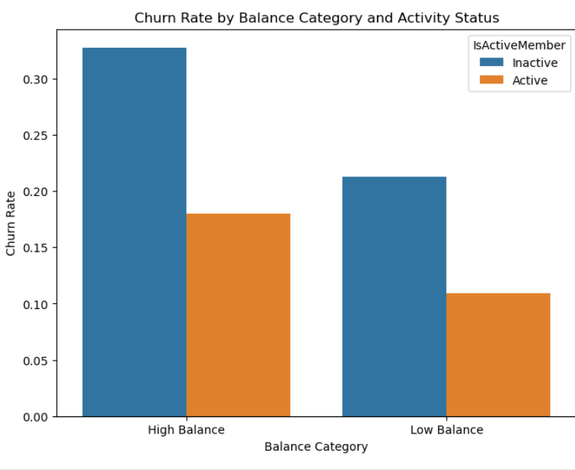

- Older Customers Show Higher Churn Rates
Customers in the middle-age segment (above 45) displayed higher churn trends

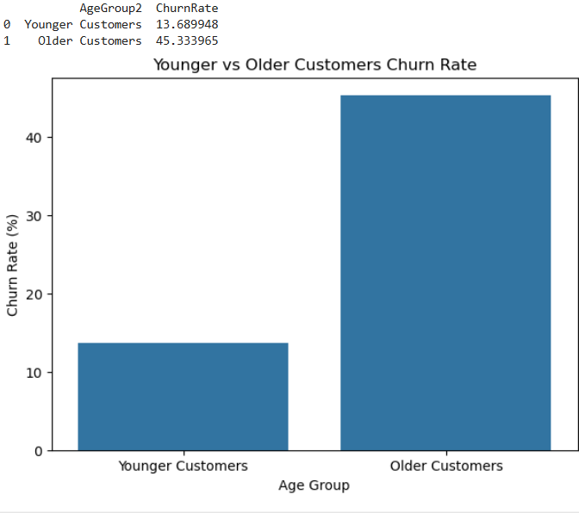

- Product Utilization Improves Retention
Customers using multiple products showed stronger engagement and lower churn.

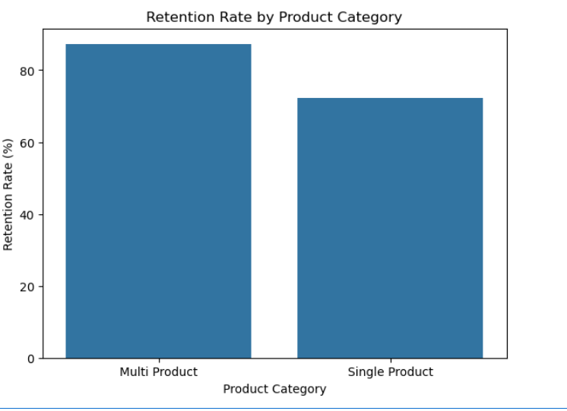

- FEATURE ENGINEERING

Feature engineering was applied to improve the predictive power of the model.

Engineered Features

Feature | Purpose
AgeGroup2_Num | Categorized age groups
SalaryGroup_Num | Salary segmentation
ProductCategory_Num | Product usage categorization
CreditTier2_Num | Credit score segmentation
TenureCategory_Num | Customer loyalty categorization

These features improved model interpretability and business insights.
8. MACHINE LEARNING MODELS

- Machine Learning models were used to predict customer churn.Multiple classification algorithms were implemented and evaluated to identify the best-performing model for Churn prediction.

Models Used
- Logistic Regression
- Decision Tree Classifier
- Random Forest Classifier
- XGBoost Classifier
- LightGBM
- SVM
- KNN

Model Training Process
- Performed train-test split with stratification to preserve class distribution.

- Smote was used to handle class imbalance.
- Models were trained and evaluated using recall for churn prediction.

Model | Accuracy | Precision | Recall | F1 Score | ROC-AUC
Logistic Regression | 0.7805 | 0.462 | 0.4791 | 0.4704 | 0.7531
Decision Tree | 0.7635 | 0.438 | 0.5774 | 0.4984 | 0.7279
Random Forest | 0.7795 | 0.463 | 0.5283 | 0.4937 | 0.7365
XGBoost | 0.7695 | 0.436 | 0.4595 | 0.4479 | 0.7265
LightGBM | 0.7660 | 0.431 | 0.4717 | 0.4507 | 0.7294
SVM | 0.7475 | 0.412 | 0.5700 | 0.4788 | 0.7239
KNN | 0.8115 | 0.560 | 0.3440 | 0.4262 | 0.6915
9.Model Performance Analysis

Interpretation of Results
Logistic Regression
Logistic Regression achieved balanced performance with good ROC-AUC score. It provided interpretable results and stable classification performance.

Decision Tree
Decision Tree achieved higher recall, meaning it identified more churn customers. However, its accuracy and precision were comparatively lower.

Random Forest
Random Forest provided strong overall performance with balanced accuracy, recall, and F1-score. It performed well in identifying churn behavior while reducing overfitting.

XGBoost
XGBoost achieved competitive performance but did not significantly outperform Random Forest in this dataset.

LightGBM
LightGBM showed moderate performance with stable classification capability and efficient computation.

Support Vector Machine (SVM)
SVM achieved higher recall but lower precision, indicating it detected more churn cases but also produced more false positives.

K-Nearest Neighbors (KNN)
KNN achieved the highest accuracy (81.15%), but its recall was low. This means it correctly classified many customers overall but failed to identify several churn customers.

Best Model Selection
Although KNN achieved the highest accuracy, Random Forest was selected as the preferred model because:
- It provided balanced performance.
- It achieved better churn detection capability.
- It handled complex customer behavior patterns effectively.
- It reduced overfitting compared to Decision Tree.
- It provided strong business interpretability.
Therefore, Random Forest was considered the most suitable model for customer churn prediction in this project.

  - THRESHOLD ANALYSIS

Threshold analysis was performed to improve churn prediction sensitivity.
Different probability thresholds were tested to balance:
- False positives
- False negatives
- Churn detection rate
This helped optimize customer retention decision-making.

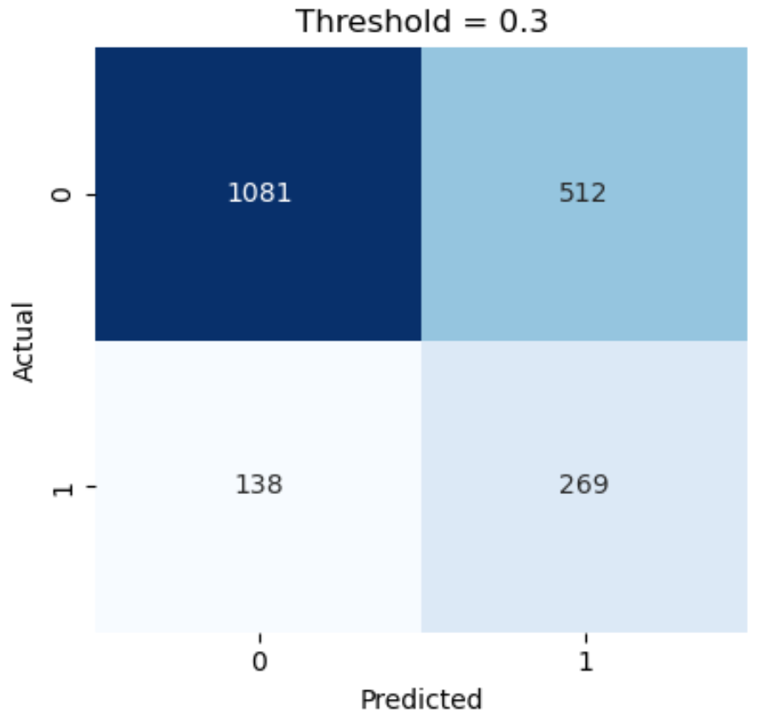

Threshold = 0.3
- Recall becomes very high
- but false alarms becomes huge
- Retention team may waste resources targeting too many safe customers.

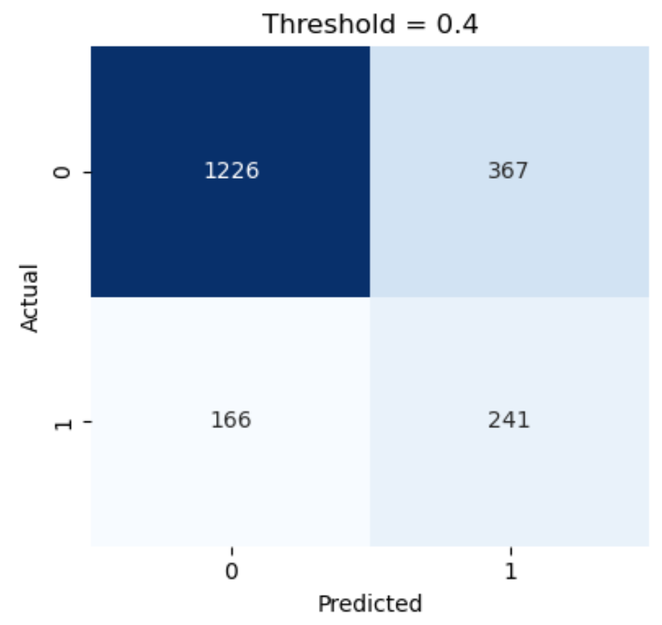
Threshold = 0.4
- good churn capture
- manageable false positives
- balanced business strategy

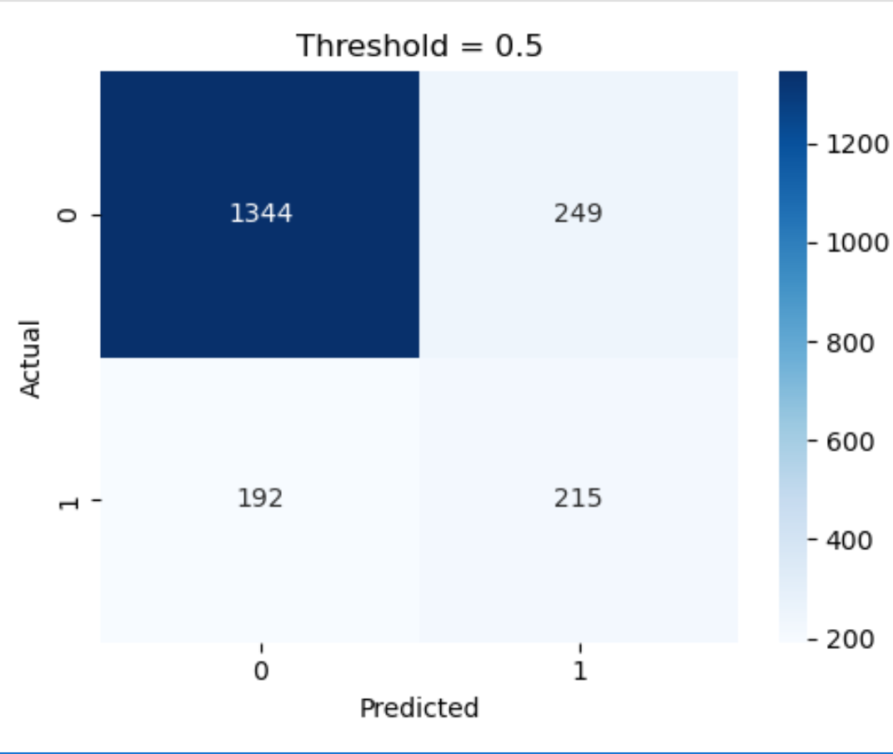

Threshold = 0.5 (default)
- Conservative predictions
- Fewer false positives
- More missed churners

Final Selection: Threshold = 0.4

  - STREAMLIT DASHBOARD
An interactive Streamlit dashboard was developed to visualize customer analytics.
Dashboard Features
1. Home Page
- KPI cards
- Customer summaries
- AI-driven overview
2. Engagement Analytics
- Active vs inactive customer analysis
- Churn overview
- Filtered customer tables
3. Product Utilization
- Product usage analysis
- High-product customers
- Product engagement trends
4. High-Value Disengaged Customers
- Detection of high-value inactive customers
- Balance-based segmentation
- Retention targeting
5. Retention Strategy Recommendations
- AI-generated retention recommendations
- Customer-specific strategies
- Retention strength scoring
6. Churn Prediction
- Real-time customer churn prediction
- User input functionality
- Prediction probability analysis
  - RETENTION STRATEGIES

- The project recommends intelligent retention strategies based on customer characteristics.

- Suggested Strategies
Customer Type | Retention Strategy
High-value inactive customers | Relationship manager outreach
Single-product customers | Cross-selling offers
Inactive customers | Engagement reactivation campaigns
Older customers | Loyalty rewards and support
High churn-risk customers | Immediate retention campaign
- These strategies help banks improve customer loyalty and reduce churn.

13. BUSINESS RECOMMENDATIONS

Based on the analysis, the following recommendations are suggested:

- Improve engagement programs for inactive customers.
- Provide personalized product recommendations.
- Offer loyalty rewards for long-term customers.
- Increase cross-selling opportunities.
- Use predictive analytics for proactive retention.
- Focus on high-value disengaged customers.
- Integrate AI-driven retention systems into CRM platforms.

14. RESULTS

The project successfully:
- Identified churn-prone customers
- Analyzed engagement behavior
- Improved customer segmentation
- Provided AI-driven retention strategies
- Built an interactive dashboard
- Enhanced business decision-making
The system demonstrates how Machine Learning and Business Intelligence can improve customer retention in the banking industry.

15. CONCLUSION

This project successfully developed a Customer Engagement and Product Utilization Analytics System for banking retention strategy.
Machine Learning models were used to predict customer churn, while Streamlit dashboards provided interactive visualization and business insights. The project demonstrated that customer activity, product utilization, and financial behavior significantly influence customer retention.
The retention strategy engine helps banks proactively identify at-risk customers and implement personalized engagement strategies.
Overall, the project provides an effective AI-driven solution for improving customer retention and banking analytics.

REFERENCES

- Banking Customer Churn Dataset
- Python Documentation
- Scikit-learn Documentation
- Streamlit Documentation
- Pandas Documentation
- Machine Learning Research Papers
- Customer Retention Analytics Literature

